MORNING SERMON
When the Heat Is Real: Fear the One Who Holds Forever

Text: Luke 12:4–5 (NKJV)
⁴ "And I say to you, My friends, do not be afraid of those who kill the body, and after that have no more that they can do. ⁵ But I will show you whom you should fear: Fear Him who, after He has killed, has power to cast into hell; yes, I say to you, fear Him!

Message: Take Eternity Seriously — Choose Christ while the door is open.

Meaning of “Fear” (Greek: phobeō ~ G5399) Vine’s New Testament Dictionary
- in earlier Greek, "to put to flight"
- in the NT is always in the passive voice,
  - “Passive Voice” Means: the receiver of the action (God or man) becomes the subject, and the doer of the action (reader) is hidden, optional, or moved to the end
- With the meanings of either:
  - to fear, be afraid,"
  - "to show reverential fear"
- For Luke 12:4-5, (a) and (b) are combined, where Christ warns His followers not to be afraid of men, but to "fear" God.

Four Truths We Must Understand About Eternity:
- What Death Is Not
- What Actually Happens at Death
- The Final Judgment
- Final Destinations

Truth #1: What Death Is Not

“Reincarnation” ~ Hebrews 9:27 (NKJV)
And as it is appointed for men to die once, but after this the judgment

“Ghost Roaming the Earth” ~ Job 14:12 (NKJV)
So man lies down and does not rise. Till the heavens are no more, They will not awake Nor be roused from their sleep.

“There is No Afterlife” ~ Luke 16:22-24 (NKJV)
²²…the rich man also died and was buried. ²³ And being in torments in Hades, he lifted up his eyes and saw Abraham afar off…

Truth #2: What Actually Happens at Death

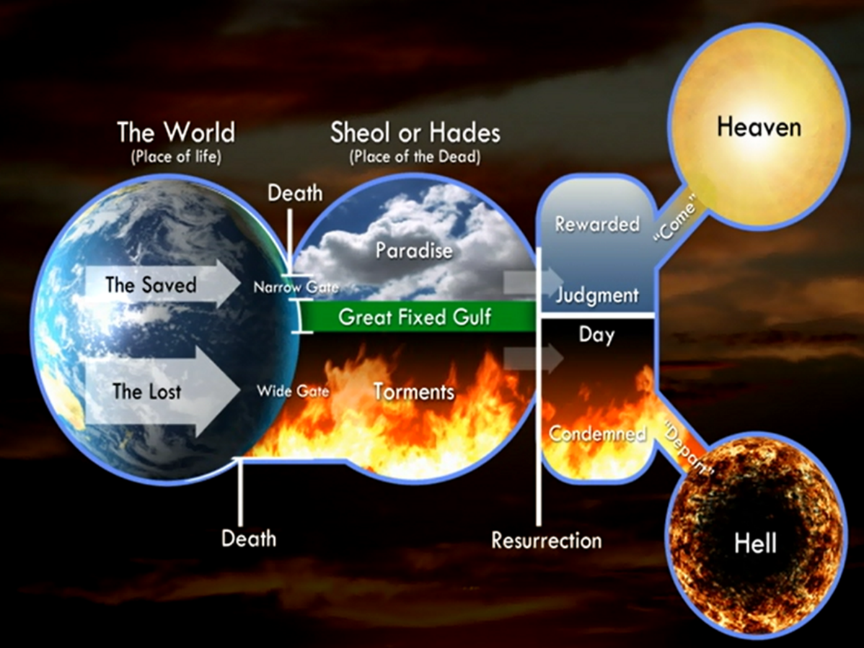

Luke 16:19–31 (NKJV) Shows Two Experiences:
¹⁹ "There was a certain rich man who was clothed in purple and fine linen and fared sumptuously every day. ²⁰ But there was a certain beggar named Lazarus, full of sores, who was laid at his gate, ²¹ desiring to be fed with the crumbs which fell from the rich man's table. Moreover the dogs came and licked his sores. ²² So it was that the beggar died, and was carried by the angels to Abraham's bosom. The rich man also died and was buried. ²³ And being in torments in Hades, he lifted up his eyes and saw Abraham afar off, and Lazarus in his bosom. ²⁴ "Then he cried and said, "Father Abraham, have mercy on me, and send Lazarus that he may dip the tip of his finger in water and cool my tongue; for I am tormented in this flame.' ²⁵ But Abraham said, "Son, remember that in your lifetime you received your good things, and likewise Lazarus evil things; but now he is comforted and you are tormented. ²⁶ And besides all this, between us and you there is a great gulf fixed, so that those who want to pass from here to you cannot, nor can those from there pass to us.' ²⁷ "Then he said, "I beg you therefore, father, that you would send him to my father's house, ²⁸ for I have five brothers, that he may testify to them, lest they also come to this place of torment.' ²⁹ Abraham said to him, "They have Moses and the prophets; let them hear them.' ³⁰ And he said, "No, father Abraham; but if one goes to them from the dead, they will repent.' ³¹ But he said to him, "If they do not hear Moses and the prophets, neither will they be persuaded though one rise from the dead."'

Luke 23:43 (NKJV)
And Jesus said to him, "Assuredly, I say to you, today you will be with Me in Paradise."

II Peter 2:4 (NKJV)
For if God did not spare the angels who sinned, but cast them down to hell and delivered them into chains of darkness, to be reserved for judgment;

Truth #3: The Final Judgment

John 5:28-29 (NKJV)
²⁸ Do not marvel at this; for the hour is coming in which all who are in the graves will hear His voice ²⁹ and come forth--those who have done good, to the resurrection of life, and those who have done evil, to the resurrection of condemnation.

II Corinthians 5:10 (NKJV)
For we must all appear before the judgment seat of Christ, that each one may receive the things done in the body, according to what he has done, whether good or bad.

Revelation 20:11–15 (NKJV)
¹¹ Then I saw a great white throne and Him who sat on it, from whose face the earth and the heaven fled away. And there was found no place for them. ¹² And I saw the dead, small and great, standing before God, and books were opened. And another book was opened, which is the Book of Life. And the dead were judged according to their works, by the things which were written in the books.
¹³ The sea gave up the dead who were in it, and Death and Hades delivered up the dead who were in them. And they were judged, each one according to his works. ¹⁴ Then Death and Hades were cast into the lake of fire. This is the second death. ¹⁵ And anyone not found written in the Book of Life was cast into the lake of fire.

Truth #4: What Happens in Gehenna

Matthew 13:41-42 (NKJV)
⁴¹ The Son of Man will send out His angels, and they will gather out of His kingdom all things that offend, and those who practice lawlessness, ⁴² and will cast them into the furnace of fire. There will be wailing and gnashing of teeth.

Mark 9:47-48 (NKJV)
⁴⁷ And if your eye causes you to sin, pluck it out. It is better for you to enter the kingdom of God with one eye, rather than having two eyes, to be cast into hell fire-⁴⁸ where 'Their worm does not die, And the fire is not quenched.'

Matthew 25:41 (NKJV)
Then He will also say to those on the left hand, "Depart from Me, you cursed, into the everlasting fire prepared for the devil and his angels:

RESPONSE TO THE INVITATION OF FAITH:
1. HEAR the GOSPEL ~ Romans 10:17
So then faith cometh by hearing and hearing by the word of God.
2. BELIEVE ~ Hebrews 11:6
But without faith it is impossible to please Him, for he that cometh to God must believe that He is and He is a rewarder of them that diligently seek Him.
3. REPENT ~ Luke 13:3
I tell you nay; but except ye repent ye shall all likewise perish.
4. CONFESS ~ Matthew 10:32-33
Whosoever therefore shall confess me before men, him will I confess also before my Father which is in heaven. But whosoever shall deny me before men, him will I also deny before my Father which is in heaven.
5. BE BAPTIZED ~ Acts 22:16
And now why tarriest thou? arise, and be baptized, and wash away thy sins, calling on the name of the Lord.

EVENING SERMON
When Forever Is Decided; The Judgment of the King

Text: Matthew 25:41-46 (NKJV)
⁴¹ "Then He will also say to those on the left hand, "Depart from Me, you cursed, into the everlasting fire prepared for the devil and his angels: ⁴² for I was hungry and you gave Me no food; I was thirsty and you gave Me no drink; ⁴³ I was a stranger and you did not take Me in, naked and you did not clothe Me, sick and in prison and you did not visit Me.' ⁴⁴ Then they also will answer Him, saying, 'Lord, when did we see You hungry or thirsty or a stranger or naked or sick or in prison, and did not minister to You?' ⁴⁵ Then He will answer them, saying, "Assuredly, I say to you, inasmuch as you did not do it to one of the least of these, you did not do it to Me.' ⁴⁶ And these will go away into everlasting punishment, but the righteous into eternal life."

Message: The King will separate all people — Not by achievements, but by allegiance

Three Truths We Must Understand About the King’s Judgement:
- The King Judges His Own
- The Nature of Everlasting Punishment
- The Final Separation

Truth #1: The King Judges His Own

Matthew 25:31-33 (NKJV)
³¹ "When the Son of Man comes in His glory, and all the holy angels with Him, then He will sit on the throne of His glory. ³² All the nations will be gathered before Him, and He will separate them one from another, as a shepherd divides his sheep from the goats.³³ And He will set the sheep on His right hand, but the goats on the left.

Truth #2: The Nature of Everlasting Punishment

Matthew 25:41-45 (NKJV)
⁴¹ "Then He will also say to those on the left hand, "Depart from Me, you cursed, into the everlasting fire prepared for the devil and his angels: ⁴² for I was hungry and you gave Me no food; I was thirsty and you gave Me no drink; ⁴³ I was a stranger and you did not take Me in, naked and you did not clothe Me, sick and in prison and you did not visit Me.' ⁴⁴ Then they also will answer Him, saying, 'Lord, when did we see You hungry or thirsty or a stranger or naked or sick or in prison, and did not minister to You?' ⁴⁵ Then He will answer them, saying, "Assuredly, I say to you, inasmuch as you did not do it to one of the least of these, you did not do it to Me.'

Truth #3: The Final Separation

Matthew 25:46 (NKJV)
And these will go away into everlasting punishment, but the righteous into eternal life."

CLOSE:

Matthew 7:13-14 (NKJV)
¹³ "Enter by the narrow gate; for wide is the gate and broad is the way that leads to destruction, and there are many who go in by it. ¹⁴ Because narrow is the gate and difficult is the way which leads to life, and there are few who find it.

This morning Jesus warned us about eternity. This evening Jesus showed us how He decides eternity.
And now Jesus Himself invites us: ‘Enter by the narrow gate… for narrow is the way that leads to life.’ The door is open now — choose Christ while you still can.”

RESPONSE TO THE INVITATION OF FAITH:
1. HEAR the GOSPEL ~ Romans 10:17
So then faith cometh by hearing and hearing by the word of God.
2. BELIEVE ~ Hebrews 11:6
But without faith it is impossible to please Him, for he that cometh to God must believe that He is and He is a rewarder of them that diligently seek Him.
3. REPENT ~ Luke 13:3
I tell you nay; but except ye repent ye shall all likewise perish.
4. CONFESS ~ Matthew 10:32-33
Whosoever therefore shall confess me before men, him will I confess also before my Father which is in heaven. But whosoever shall deny me before men, him will I also deny before my Father which is in heaven.
5. BE BAPTIZED ~ Acts 22:16
And now why tarriest thou? arise, and be baptized, and wash away thy sins, calling on the name of the Lord.
6. BE FAITHFUL UNTO DEATH ~ Revelation 2:10
Fear none of those things which thou shalt suffer: behold, the devil shall cast some of you into prison, that ye may be tried; and ye shall have tribulation ten days: be thou faithful unto death, and I will give thee a crown of life.

